**Bank Management System**

Create a bank management system where-

**User**

1. Can create an account.
2. Can deposit and withdrawal amount.
3. Can check available balance.
4. Can check transaction history.
5. Can take a loan from the bank three times
6. Can request for loan
7. Update profile information

Note - User can only withdraw and transfer money from his account if he has money in his account.

**Admin**

1. Can create an account
2. Can check the total available balance of the bank.
3. Can approve the loan request

**Code link :**

**https://github.com/abdullahallnaim/django-codes/tree/master/mamar_bank**

**Some Features you can work for :**

1. Can transfer the amount from his account to another user account.
2. If a user is unable to withdraw the amount of money he has deposited in the bank, he will get a message that the bank is bankrupt.
3. Password change form
4. Add profile picture
5. Add some unique features by yourself and you can also change the color gradient of this project

**Register page :**

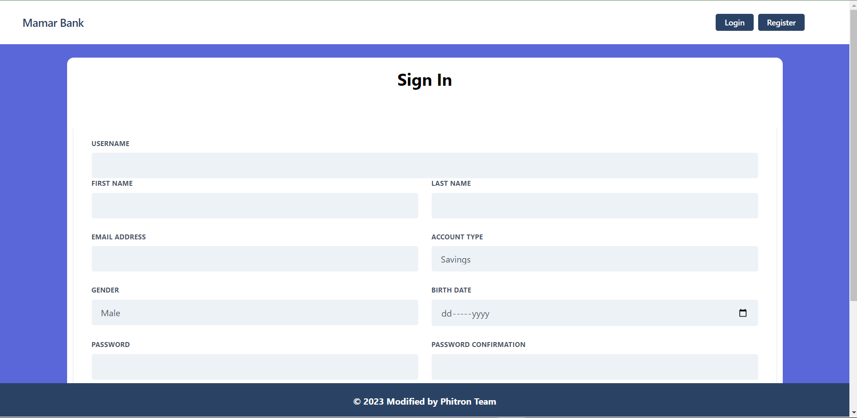

Login Page :

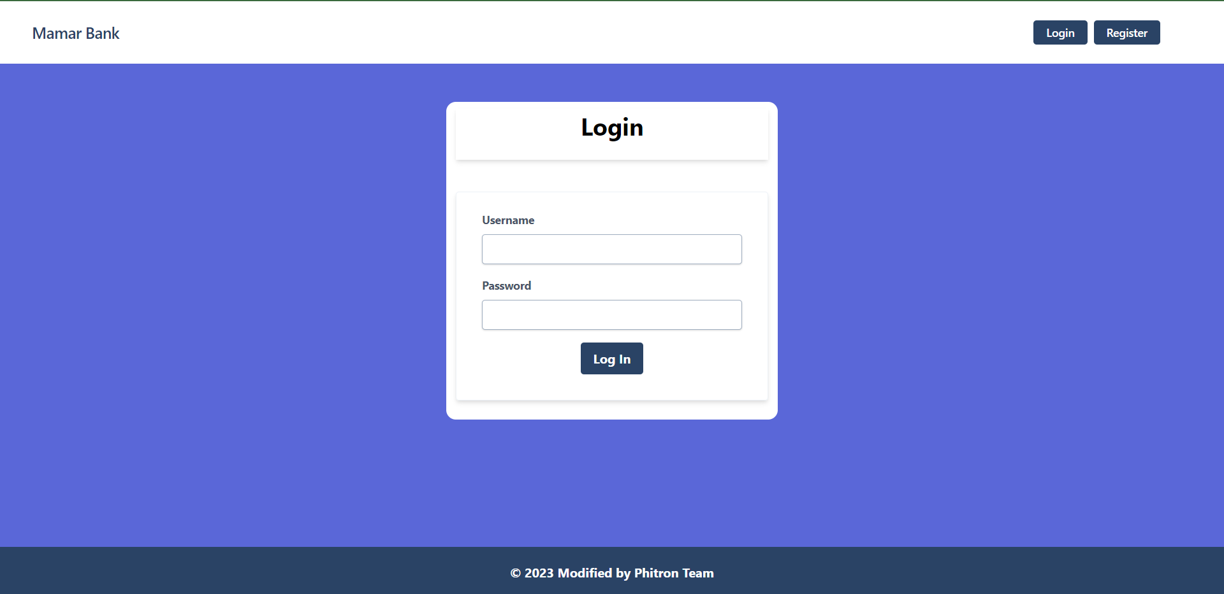

**Transaction Page :**

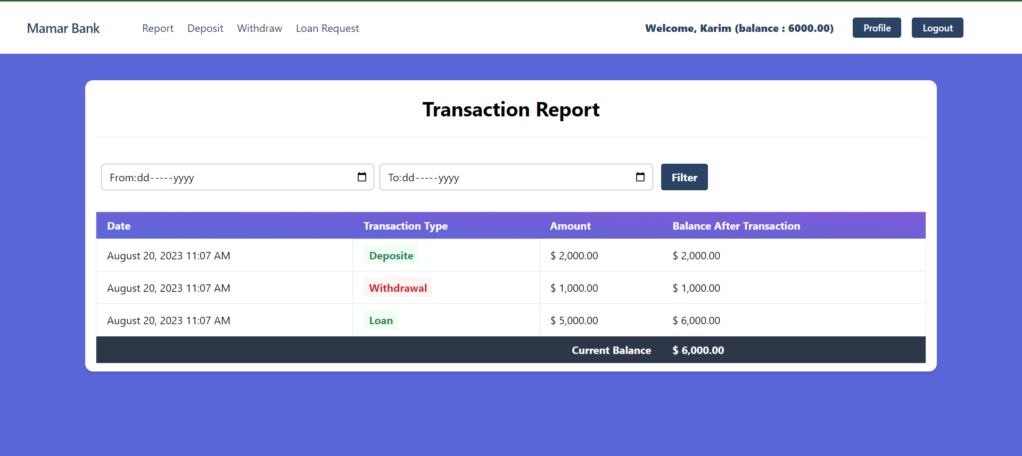

**Deposit page :**   
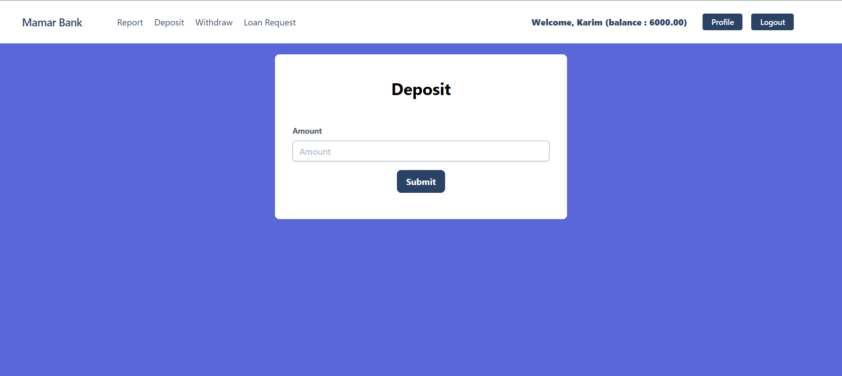

**Withdraw page :**

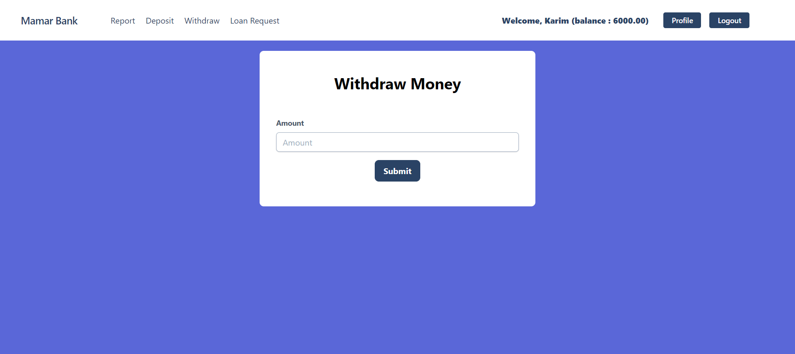

**Loan Report :**

